**TASK 2.3**

**1.Pie Chart**

I have used pie chart here because I am using only 2 variables(population less than 65 and population over 65 age).This is good choice for comparing 2 different variables and clearly see the difference of both variables.I have used color schema to differentiate both variables in pie chart.I have used Title and lables for good visualization.

<https://public.tableau.com/app/profile/aarthi.subramanian/viz/Trial_17144698764520/PieChart?publish=yes>

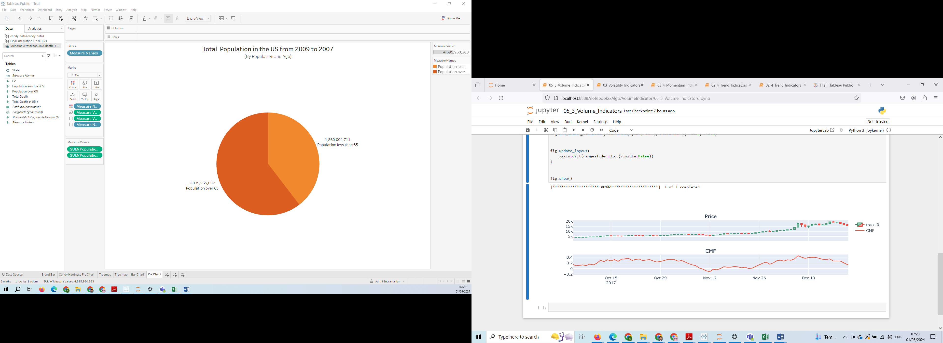

**2.Bar Chart**

I have used stacked column chart to show population less than 65 and over 65 for all states in US.I have used color schema for better understanding.

<https://public.tableau.com/app/profile/aarthi.subramanian/viz/Trial_17144698764520/BarChart?publish=yes>

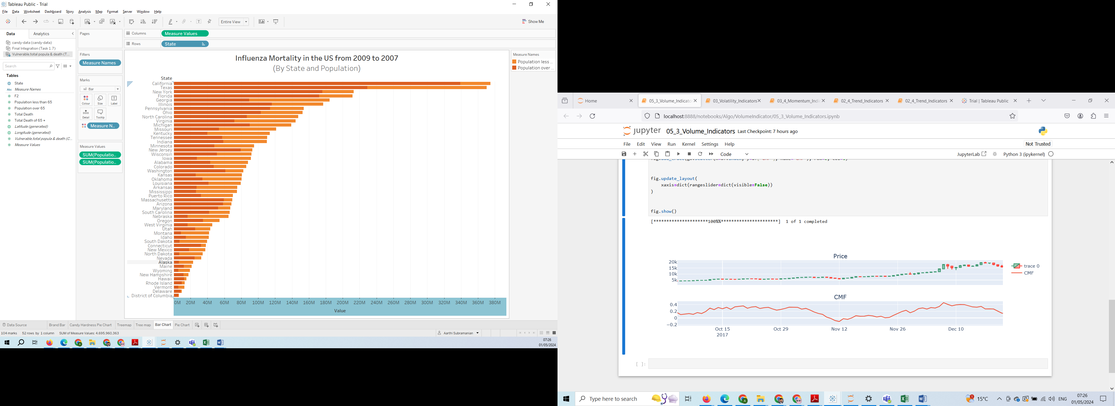

**3.Treemap**

I have used Treemap here to visualize all states with total death in that states of US from 2009 to 2017.

<https://public.tableau.com/app/profile/aarthi.subramanian/viz/Trial_17144698764520/Treemap_1?publish=yes>

